5Mobile Systems transmit & receive data packets and bit-errors can occur due to noise affecting radio reception. We can try to achieve error-free packet transmission by:

1. Forward Error Correction (FEC)
2. Error detection and retransmission (ARQ)
3. A combination of 1 and 2

**Forward Error Correction**

This scheme relies on the correction of bit-errors at the receiver, based on information redundancy built into the transmission by:

* appending check bits or
* ‘coding‘ to produce larger packets.

Either block coding or convolutional coding may be used.

A FEC decoder tries to correct any bit-errors, and can check whether all bit-errors have been corrected. If all else fails, ARQ can be requested (retransmission) if bit-errors remain.

**Block & convolutional coding**

Block codes are used for *both* error detection and correction, whereas convolutional is generally used for bit-error correction.

Block codes require the whole block of data to be available before it can be coded at the *transmitter.* Then the complete block of data must be fully received at the receiver end before decoding can begin.

Convolutional coding can start as soon as a few bits are available, and can go on uninterrupted. A convolutional decoder can start producing an *error-corrected bit-stream* once around 50 bits have been received. Both processes (in principle) can continue for as long as the transmission and receipt of data is occurring.

A simple block coding idea: parity

* 1010 has even parity as the number of ones is even. XOR on 1,0,1 and 0 is 0.
* 1011 has odd parity, and XOR on the digits is 1.

A transmitter can append the ‘parity bit’ to a 4-bit number to force parity to always be even, eg

1010**0** or 1011**1.**

Therefore the receiver calculates the parity of received messages using the **XOR of 5 bits**. If the parity is odd, a bit-error must have occurred somewhere within the 5 bits. If the parity is even, the data *may* be correct, or there may be an even number of bit-errors.

We could do the same but however test for odd parity instead, with even parity denoting a bit-error occurred.

**Hamming distance** is the number of bits that are different between two binary numbers. Obtained by XOR-ing & counting the number of 1s.

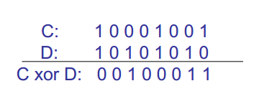

Here the hamming distance between C and D is 3. So clearly there are 3 bit-errors present.

Let the **minimum Hamming distance** between any 2 numbers be **d**.

Error *detection* is possible if the number of bit-errors < **d**.

Error *correction* is possible if the number of bit-errors <= **(d-1)/2**

The minimum Hamming distance is very important in error detection and correction. If we assume four binary numbers with a min Hamming distance of 5: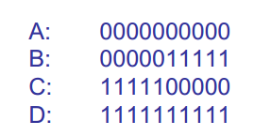

If we receive B with 2 bit-errors, it will be at distance of 2 from B and at least 3 from all others (similar situation with 1).

Taking the shortest distance, we can **correct** received number to B.

However for 3 or 4 bit-errors, we can **detect** that they are there *but* trying to correct by finding shortest distance to closest number will produce the wrong result.

**Hamming codes**

Assume if you are sending ‘m-bit’ messages, we will introduce r check-bits chosen to make **d** = 3. This allows the *detection* of single and double bit-errors, and the *correction* of a single bit-error. We must be aware that bit-errors can occur in check-bits as well as message bits.

Hamming codes of length 7, message length being 4 and number of check-bits being 3, are what we shall look at further. With m=4 and r=3, we get a (7,4) block code whose ‘rate’ is 4/7 (4 message bits per 7 bits sent).

Let message bits to transmit be B0 to B3.

Add 3 extra bits P0 to P2.



We make the following combinations all have even parity:

* B3, B2, B1, P0 (**miss out B0**) - set P0 to the XOR combo of B3, B2 and B1.
* B3, B2, B0, P1 (**miss out B1**) - set P1 to the XOR combo of B3, B2 and B0.
* B3, B1, B0, P2 **(miss out B2**) - set P2 to the XOR combo of B3, B1 and B0.

So at the receiver end we calculate the same “receiver parities” by missing out the relevant B bit.

* R0 = B3, B2,B1,P0 XORed
* R1 = B3, B2,B0,P1 XORed
* R2 = B3, B1,B0,P2 XORed

If no bit-errors, R0, R1 and R2 will be 0. We can check if either B0 up to B2 are in error if the other 2 receiver parities are 1. Eg. if B0 is in error, R1 & R2 will be 1, etc.

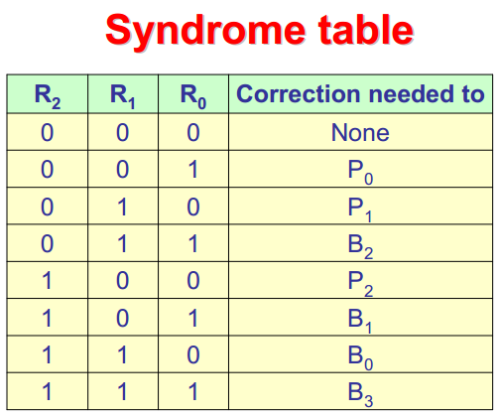

**Interleaving**

Radio links often suffer bursts of errors. Transmitting a block by column ensures only a single-bit error per codeword row.

**Cyclic redundancy check (CRC)**

Another example of a block code but only for bit-error detection.

Suppose we are transmitting a decimal number 139. We divide by a ‘generator’ 7 and take the remainder, and express it in binary. We get 19 with remainder 6, or 110 in binary.

We use 110 as the check-bits. The same division is done at the receiver, if we get a different number, a bit-error has occurred.

The ‘generator’ number 7 is agreed in advance and carefully chosen.

*However not all combinations of bit-errors can be detected by this method.*

* Any combo that adds or subtracts multiples of 7 are not detected.

**Real CRC checks and polynomials**

A decimal number may be expressed as a polynomial:

$139 = 1 * x^{2 }+ 3 * x^{1} + 9 = p(x)$

Binary numbers may be expressed as a polynomial:

10011001 = $x^{7} + x^{4} + x^{3} + 1 = p(x)$

Real CRC checks do not use normal arithmetic. They use a different way of ‘dividing’ based on XOR. It is modulo-2 /Galois field (base 2) arithmetic.

Summing or subtracting bits involves looking at each bit in each position and XORing the two.

Limitations of CRC

Not all combinations of bit-errors are detectable by a CRC. Any combination of bit-errors that adds any ‘multiple’ of G(x) (our generator number) will not be detected. We can try to make this unlikely by making the order of G(x) large.

A G(x) of order **r** cause all error ‘bursts’ of length <= **r** to be detected.

Standard CRC generators include CRC-8-ATM, CRC-16-IBM, and CRC-32-IEEE.

**Convolutional Coders**

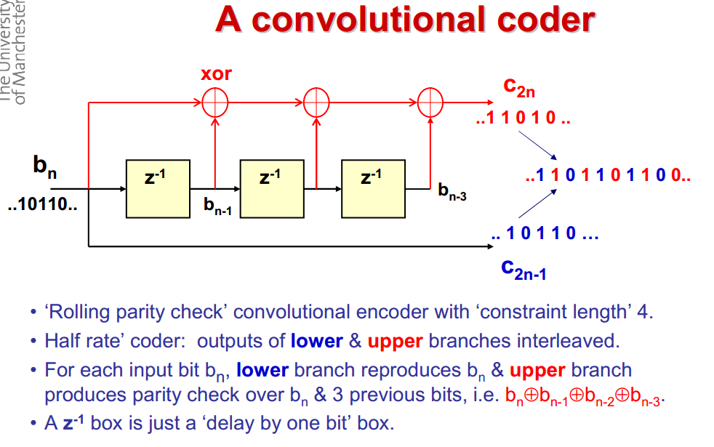

The lower table works through bn (10110), left-to-right, and we assume missing bits are ‘0’.

**Lower** simply feeds bn through, **upper** performs XOR operations on the current bit and the 3 bits before it. Then we interleave the branches **(lower part first)**.

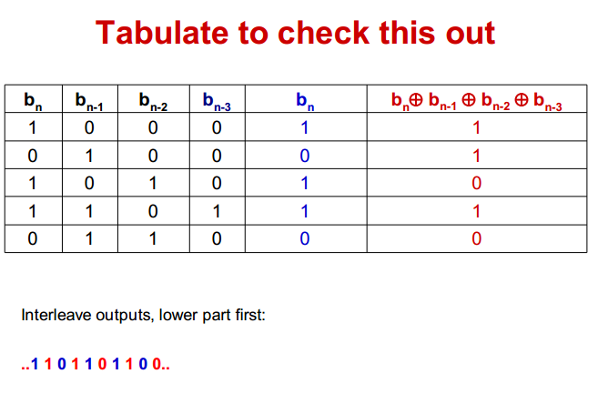

Decoder Strategy

The encoder generates ‘valid’ sequences where each upper bit is the XOR of all previous 3 lower bits. How ever bit-errors can make this received bit-sequence ‘invalid’.

We select the valid sequence with the *minimum Hamming distance* to the received sequence, as the error-corrected sequence. We can do this for short sequences of bits (eg 8), but it becomes infeasible for longer sequences(eg 1024).

A **Viterbi decoder** uses the [Viterbi algorithm](https://en.wikipedia.org/wiki/Viterbi_algorithm) for decoding a bitstream that has been encoded using a [convolutional code](https://en.wikipedia.org/wiki/Convolutional_code).

Conv. coders are used widely in mobile systems, and Viterbi efficiently decodes them.

Viterbi decoders use ‘soft decisions’, instead of just 1 and 0.

0.25 = ‘probably 0’, 0.5 = ‘don’t know’, 0.75 = ‘probably 1’

‘Rolling parity’ conv. coder is:

**Systematic** - as original code appears in coder output.

Of **constraint length 4** as there are three z^-1 output boxes.

The rolling parity coder was *presented for simplicity, this is the conv. coder used widely in practice.*

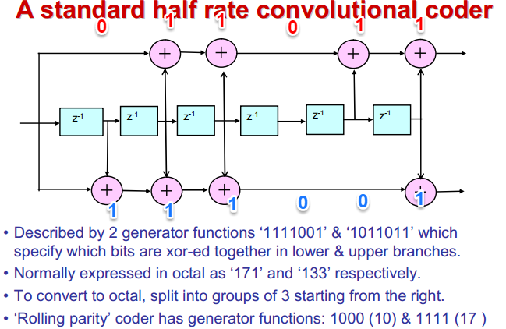

1 **011 011 -> 133 in octal**

1 **111 001 -> 171 in octal**

The ‘generator’ functions denote when perform an XOR, 1 means XOR, 0 means do not (see above diagram). On the **red** path we take bn and XOR it with $b_{n}$, not $b_{n-1}$, as we encounter a ‘0’ (don’t XOR) and then a ‘1’ (XOR). After each XOR operation on a branch, we take the result and then use that as one of the inputs for the next XOR operation we encounter, and take the other input as the next $b_{n-x}$ bit in the input sequence of bits.

Funnily enough, this example is better explained in a *model answer* for last year’s past paper:

(obviously spoilers ahead if you want to attempt the question yourself first).

**NB. The diagram is wrong, blue output should be 1110 as in the table.**

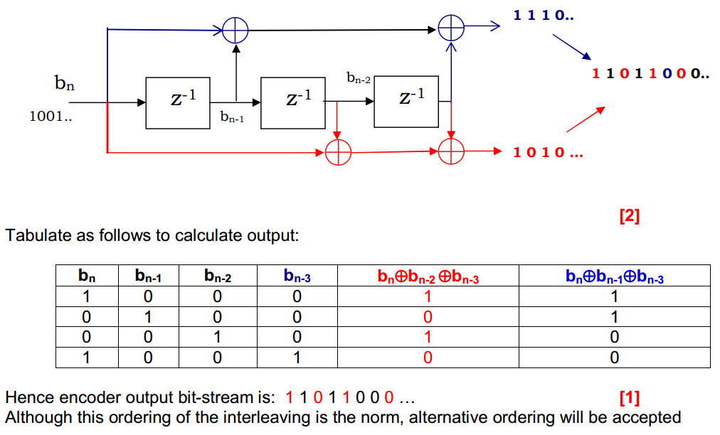

Coder also of constraint length 4. (3 $z^{-1}$ boxes).

Here we can see the **upper blue** branch performs XOR on $b_{n}$ and $b_{n-1}$, then takes that result and performs XOR on the result on $b_{n-3}$ (because of the gap between the XOR operations).

Similar with the red, lower branch. Comparing this coder with the simpler, earlier coder may help your understanding.

**Advantages of FEC for mobile systems**

Use of FEC in cellular mobile systems increases energy efficiency and effectiveness.

Transmitting at a higher power is one way of making sure a signal is received with fewer errors, but high power signals cause and carry further interference over a wider range, and also quickly depletes a battery.

Solution is to reduce transmission power and deal with resulting increase in bit-error rate using FEC. Solves cellular frequency reuse problem and reduces power consumption.

**Shannon-Hartley Law**

The **Shannon–Hartley theorem** tells the maximum bit-rate at which information can be transmitted over a communications channel of a specified bandwidth in the presence of ‘additive white Gaussian noise’ and an arbitrarily small bit-error rate.

The channel capacity C is expressed as:

$C = B \log_{2}(1+S/N) [bits/s]$

Where B is Bandwidth in Hz.

S/N = signal **power** / noise **power** ratio (**not** in dB).

SNR = 10 $\log_{10}(S/N)$*signal-to-noise ratio* in dB.

If SNR >> 1, then we can use $C≈0.332 * B * SNR$